Please replace this page with your title page including your name, workplace and level of portfolio.

Expert Portfolio Contents
- Application Letter - signed
- Curriculum Vitae
- Copy of entry on online NCNZ register showing current APC
- Copy of Job Description
- Current Performance Development Review or PDR (within the last 12 months) – signed – This includes the self and competence assessment against the NCNZ competencies.
- Manager Support Letter - signed
- Professional Development or Career Plan
- Verification of 450 practice hours over the last three years, validated by a senior nurse (e.g. CNM) - signed
- Evidence of 60 Professional Development Hours over the past three years – signed
- Reflections on three Professional Development activities
Expert Requirement
- Evidence of post graduate education (level 8 papers) relevant to area of practice or equivalent. This may have been complete before the 3 years under certification and does not expire as long as the applicant has maintained continuing professional development.
- Evidence demonstrating contribution to specialty knowledge OR innovation in practice and the change process in quality improvement activities, including evidence of implementation evaluation and manager support.
- Reflection on the learning and/or development of colleagues.
- Evidence demonstrating engagement and influence in wider service, professional or organisational activities. Highlighting advocacy for nursing needs to be included.
- Reflection demonstrating expert knowledge and application of expert practice in the care of complex patients and clinical leadership in care coordination.

Application Letter

Please complete all sections below
(please note, with the exception of Graduate Nurses, certificates are issued to Proficient, Expert and Accomplished level only)
Name as you want it to appear on your certificate (please print clearly in the box below):

APC Number |  |  |  |  | Expiry Date:
Workplace:
Manager Name: |  |  |  |  | Title:
This portfolio is for: Registered Nurse
This portfolio is for (please circle): Maintenance Progression
This portfolio is for (please circle): Competent Proficient Expert Leadership

Declaration (Please tick all applicable)
 | I declare that the documents in this portfolio are my own work and if taken from papers, journals or books, are appropriately referenced
 | I declare that where I have submitted joint work, I have fairly and accurately described my personal contribution
 | I declare that the enclosed work (related to practice situations) has occurred in the previous three years and relates to the current competencies of my scope of practice
 | I am prepared to provide authentication data confidentially to the moderator or assessment panel of required
 | I understand this material remains confidential to the assessor(s) unless covered under the Health Practitioners Competence Assurance Act 2003
 | I am aware that my portfolio may be subject for use in the moderation process, internal, external or as directed by the New Zealand Nursing Council and I will make my portfolio available within 2 weeks if required for moderation
 | I understand than none of my work will be used for any other purpose unless it has my specific consent
 | I declare that this portfolio represents a consistent demonstration of my practice
Signature: |  |  |  | Date:

Please remove this page and insert your CV here.

Please remove this page and insert a print out of your Nursing Council of New Zealand registrations entry from:
www.nursingcouncil.org.nz

Please remove this page and insert a copy of your Job description.

Please remove this page and insert a signed copy of your Annual Performance Development Review (PDR). Please ensure that this:
- Signed
- Less than 12 months old
- A Full PDR not an interim (a Full PDR contains the self and competence assessment)

Manager Support Letter

Applicants name:
Applicant last Appraisal date:
Manager name: |  |  |  |  |  |  |  |  | Manager’s Title:
Tick as appropriate
 | I have no concerns about this nurse applicant’s performance, practice, manner, attitude or teamwork
 | This applicant has not been under review for poor performance or conduct in the past 12 months
 | This applicant’s most recent appraisal accurately reflects her/his nursing ability
 | This applicant consistently practices by demonstrating appropriate standards of knowledge, documentation, motivation, collaboration, and effective teamwork
 | I have been consulted on and have approved the applicant’s quality initiative, practice change, contribution to specialty knowledge or innovation in practice. This meets Wairarapa DHB, Hutt Valley DHB or the employing organisations requirements where necessary.
 | This applicant demonstrates a commitment to improving her/his practice and being involved in professional development and practice initiative activities
 | I have read the applicant’s portfolio and agree that it is a true reflection of their performance
 | I support the applicant for progression or maintenance on the PDRP pathway at:
 |  |  | Competent Level |  |  |  | Proficient Level
 |  |  | RN Expert Level |  |  |  | RN Senior
 | I do not support this applicant for progression on the PDRP pathway
Reason/comments:

Signed: |  |  |  |  |  | Date:

Please remove this page and use EITHER the following professional development plan or career plan

Professional Development Plan

Name: |  |  |  |  |  |  |  | Signature: |  |  | Designation:
Date: |  |  |  |  | Workplace: |  |  |  |  |  | APC Number:
Goal | Links (what professional, service or DHB imperative does the goal address) |  |  |  |  | Activities (steps/actions required to achieve goal) |  | Resources Needed  (including personnel, access, time, financial) |  | Expected Outcome (impact on professional growth, service delivery or consumer)
E.g. | Improve services to inpatients with mental health issues |  |  |  |  | Mental Health Study Day  Work with mental health nurse |  | Access to the Mental Health Study day. Time to work with a mental health nurse. |  | Improve care I give patients with mental health issues within the ward and to support junior colleagues to develop better skills in assessment and management of patient’s mental health status.
1

2

3

PROFESSIONAL DEVELOPMENT & CAREER PLAN
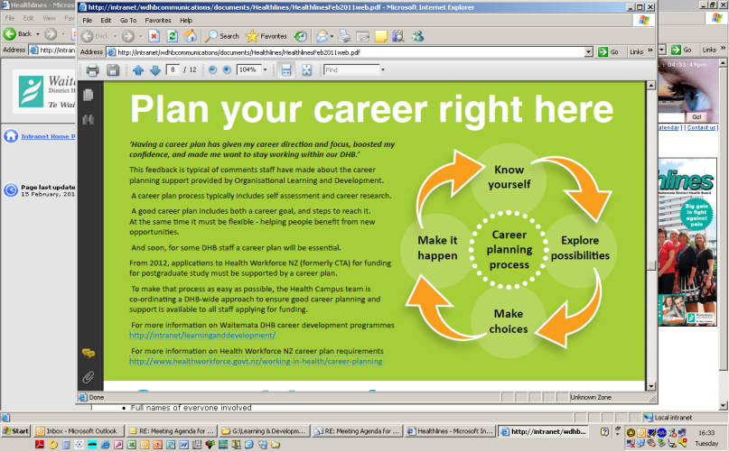
NURSING
Career planning is a continuous process of self-assessment and goal setting. This plan incorporates your career and professional development aspirations and aligns these with organisational goals as reflected in your role description. The Directors of Nursing manage HWNZ funding for nurses. A requirement for accessing this funding is to attain the appropriate level of the Nursing Professional Development and Recognition Programme (PDRP) and have an agreed Professional Development and Career Plan (PDCP). Professional development activities require a feedback loop (report on outcomes) as part of the follow-up for activities supported by the organisation. This link provides further information on the career planning process. http://www.healthworkforce.govt.nz/health-careers/career-planning. Before starting your career plan, it’s important to work through the career planning process, so that your plan is realistic and achievable for you, taking into account your self assessment (Know Yourself) and your career research (Explore Possibilities). Consider what knowledge and skills you need to fulfil the role description (i.e. clinical competences and professional behaviours) and meet objectives and develop in your career.
Career Plan for: |  |  |  |  |  | Date:
 |  | Career &/or Professional Development Goals | Action Plan to Achieve Goals |  |  |  | Timeframe for achievement

Short Term

(within 1 year)

Longer Term

(up to 5 years)
I have discussed my professional development and career aspirations with my line manager who is in agreement. |  |  |  | The plan meets the needs of the service and fits with the strategic direction of workforce development within the organisation. I have discussed this plan and agree to support the achievement of these goals.
Staff Member Sign Off: |  |  |  | Line Manager Sign Off:
Name: |  |  |  | Name:
Title: |  |  |  | Title:
Signature: |  |  |  | Signature:
Date: |  |  |  | Date:

Please remove this page and insert validated verification of 450 practice hours in the past 3 years. The following can be used:
- OneStaff printout – signed by senior nurse/manager
- Printout from HR/Payroll
- Signed letter from CNM/Manager detailing the total hours you have worked in the past 3 years

Please remove this page and insert validated verification of 60 Professional Development hours in the past 3 years. The following can be used:
- OneStaff or Trendcare print out signed by senior nurse/manager
- HR/Payroll printout
- Printout from your organisation signed by your manager
- Professional Development List signed by senior nurse/manager (see next page)

Professional Development List
Name: |  |  |  | Signature: |  |  |  | Designation:
Date: |  |  |  | Workplace: |  |  |  | APC Number:
Date of Training |  | Hours | Activity (Name of course/education session) |  |  |  |  |  | Hosted by (place course held)
Total hours
Verification by manager: |  |  |  |  | Date: |  | Signature:

Professional Development Reflections
Name: |  |  |  | Date:
Date of Training | Hours | Activity (Name of course/education session) | Reflection (Explain what you learnt from this activity – how it affirmed or influenced your practice)

Please remove this page and insert evidence of your post-graduate education. If applying for equivalence please include the appropriate completed form available from the PDRP coordinator or from the internet/intranet.

Please remove this page and insert your evidence demonstrating contribution to specialty knowledge OR innovation in practice and the change process in quality improvement activities, including evidence of implementation evaluation and manager support.
This should include:
- PLAN – why did you do the quality initiative or practice change.
- DO – evidence of the quality initiative or practice change including pictures, leaflets, hand outs, training, documents, policies or other work developed as part of this change.
- REVIEW – Evidence that your quality initiative or practice change has been evaluated by others.
The following document could be used as a template for this.

Quality Improvement Project Plan
Unit:

PLAN

D
O

CHECK

ACT
Person Responsible:
Team members:
Project Title:
Issue:
Target Group:
Aim:
Action Plan
Results:
Evaluation:
Feedback:

On completion send copy to: Service Manager Quality Manager
Unit Manager Signature: | Date:
Comments:

Please remove this page and insert your reflection on the learning and/or development of colleagues.

Please remove this page and insert your evidence demonstrating engagement and influence in wider service, professional or organisational activities, highlighting advocacy for nursing needs to be included.
The following template should be used for this.

Evidence of involvement in wider service, professional or organisational groups / forums
 |  | Comments
Name of Professional Group/Forum
Group purpose / focus
Personal specific activities / role within the group
Outcomes Activity
Impact on Clinical practice
Impact on Nursing/Midwifery profession
Recommendations for Practice Setting
Personal reflections on participating in the group.
SIGNED: |  |  | DATE:
SIGNED BY MANAGER: |  |  | DATE:

Please remove this page and insert your reflection demonstrating expert knowledge and application of expert practice in the care of complex patients and clinical leadership in care coordination.

