Once you have been migrated onto the new Windows 7 / Citrix environment, you will be able to remotely access the Hutt Valley DHB network from any internet capable device.

To do this you will need to download the “Citrix Receiver” onto any device you wish to use to connect to Hutt Valley DHB.

Just follow these three steps.

- In your web browser go to www.huttvalleydhb.org.nz
- Navigate through “Health Professionals”, select DHB Web Applications and click on “Windows 7 Staff Logon”
- You will be prompted to install the Citrix ICA Client if it is currently not installed on your device – if installed, log in as you would normally do from work computer using your Windows 7 username and password

Please see below for more detailed instructions including screenshots:

Step By Step Guide on installing Citrix on your home PC and accessing your Hutt Valley DHB Environment:

From your remote device browse to www.huttvalleydhb.org.nz

Select DHB Web Applications, and under Hutt Valley DHB, click on Remote Desktop Logon

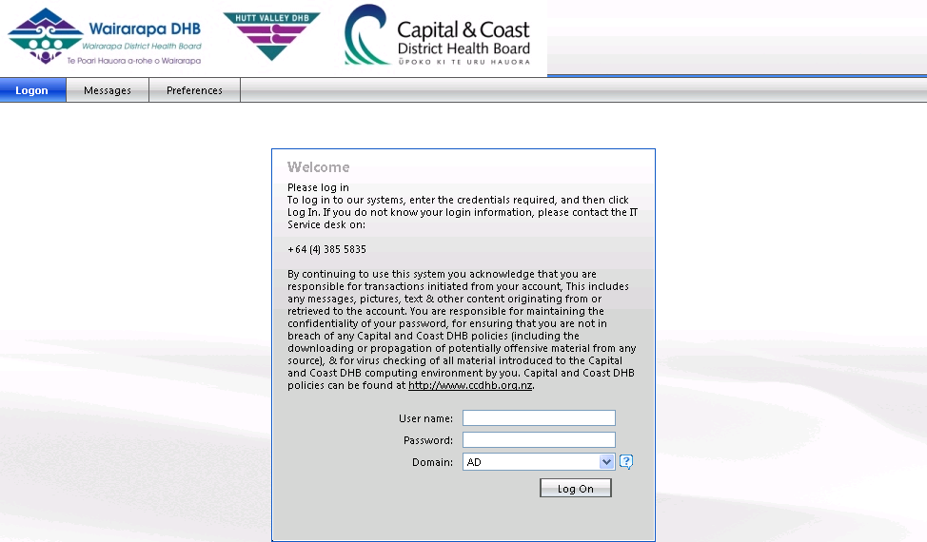

Type in your Windows 7 username and password (you do not need to type in ad/)

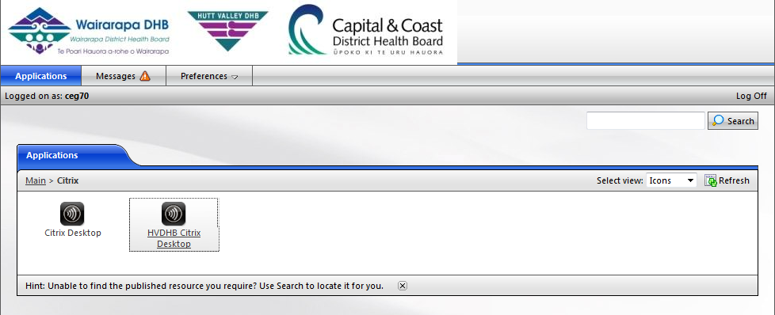

If you do not currently have the ICA Client installed, you will be automatically prompted to install. Please note the following instructions might differ slightly depending on the device, internet application or operating system you are using.

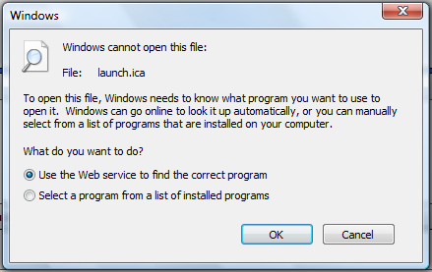

Click OK on the following message

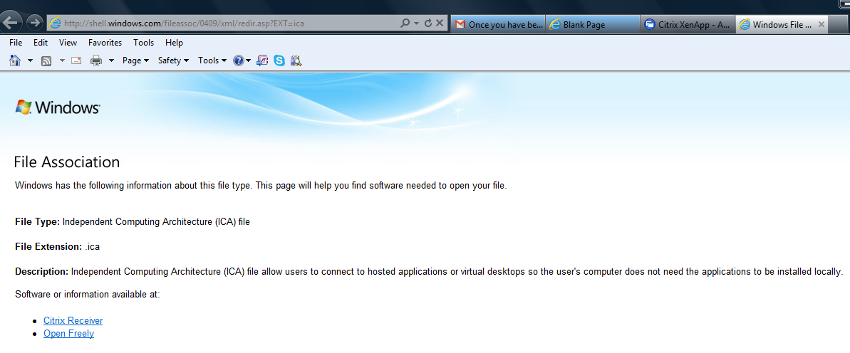

Select Citrix Receiver

Select Download Citrix Receiver

Select Download Receiver for Windows (if you are downloading onto a MAC, or other device, it will automatically detect correct receiver to download)

You can install this on any internet capable device including (but not limited to):
- iPhone
- Android devices
- Tablets
- Laptop
- iMac
- Home Computer
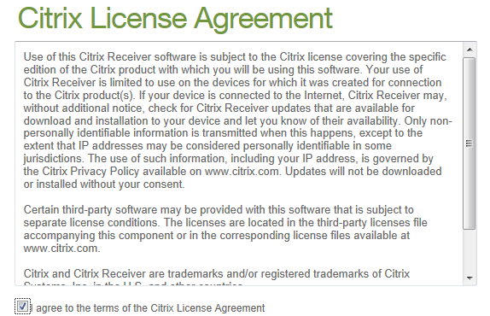

Tick ”I agree to the terms of the Citrix License Agreement”
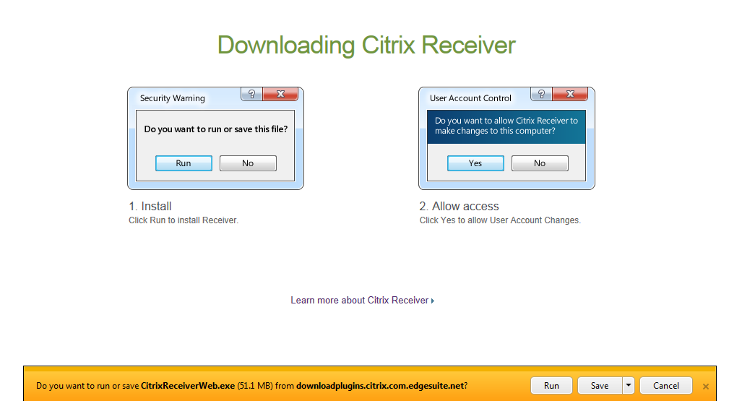

Select Run.

Once download is complete, you will be prompted to log into the Hutt Valley DHB environment as you would from work.

Please Note: Only applications available your current Citrix environment will be available remotely

