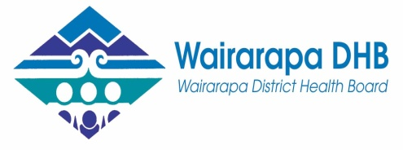
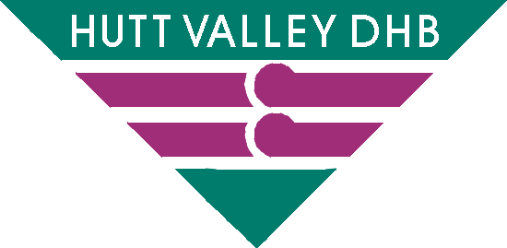
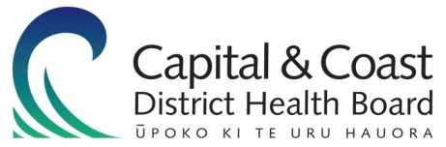

Health Board Disability Plan
2013 – 2018
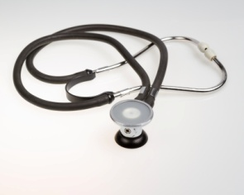

Easy-Read

The health needs of disabled people

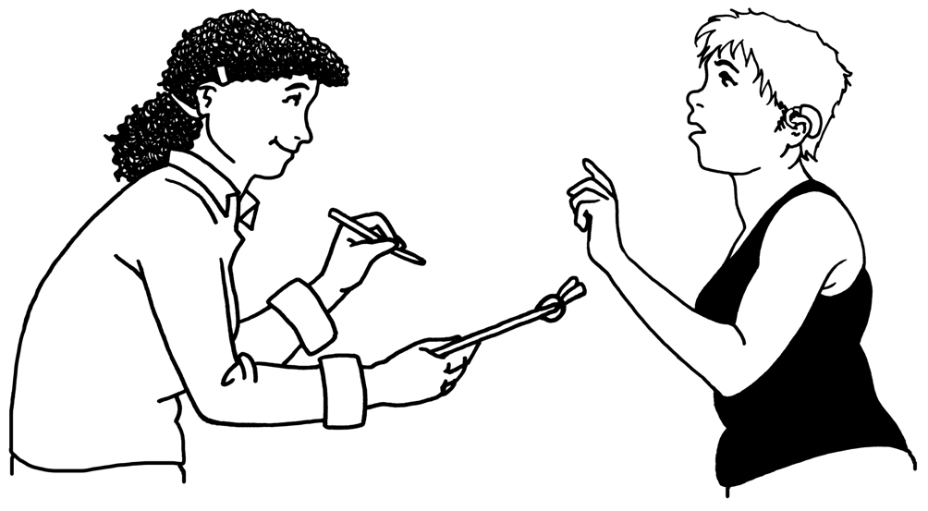
In 2006 the Government did a survey called a census.

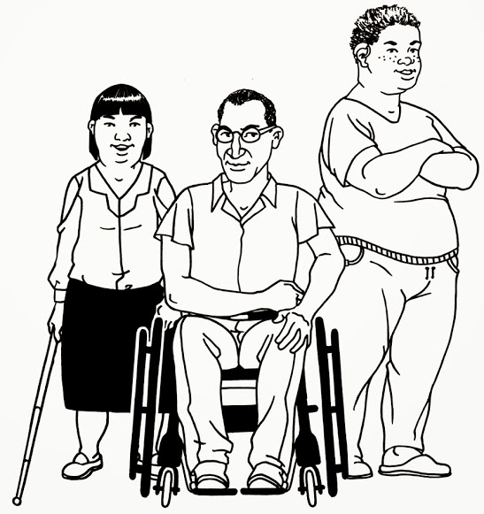
The survey showed that 20 percent of people in New Zealand had a disability.

More surveys show that around 30 percent of people in hospitals have a disability.
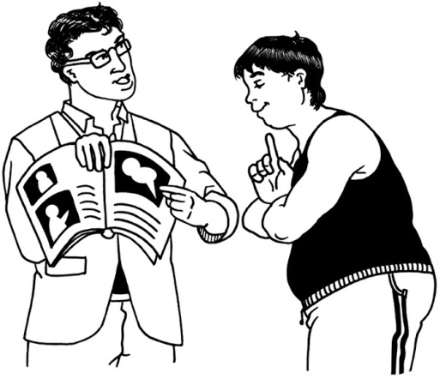
Across the world there is not much information about the health needs of disabled people.

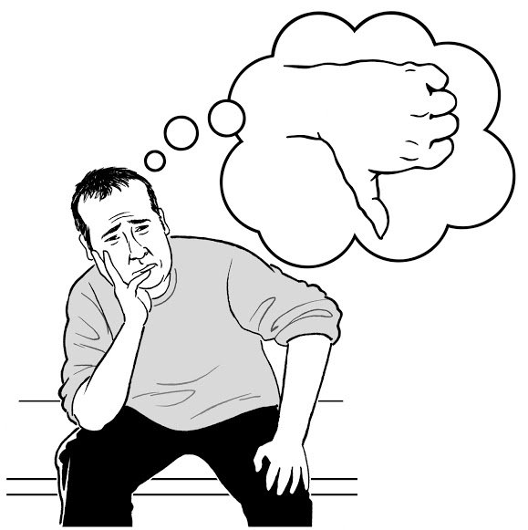
People with disabilities sometimes have lots of problems with their health.

This needs to change.
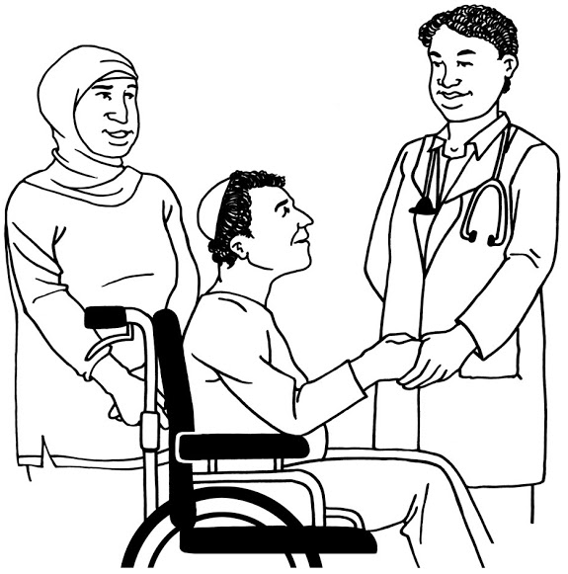

It is important that disabled people have good healthcare.

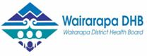
In 2005-2009 the Wairarapa District Health Board had a disability plan.

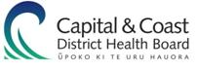
In 2012 a disability plan was made by the District Health Boards in:

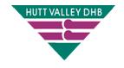
- Wellington and the Kapiti Coast

- Hutt Valley.

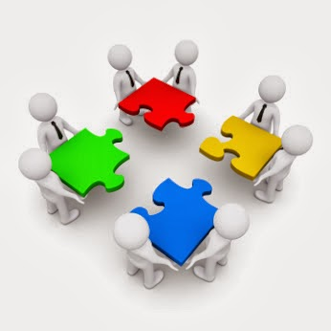
The Boards in these 3 places are now going to work together and have 1 disability plan.

Working together

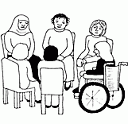

In June 2013 there was a forum to talk about the health needs of disabled people in the lower North Island.

Everyone wanted better health for disabled people.

People at the forum said that the health boards need to have one plan for disability.

Making the Plan

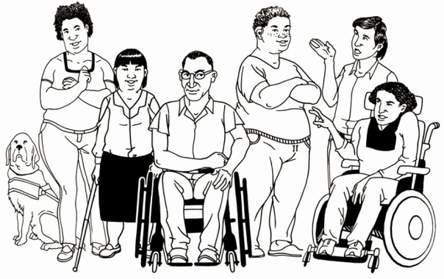
The new Disability Plan will be made by a Disability Advisory Group.

The ideas that people talked about at the forum will be part of it.

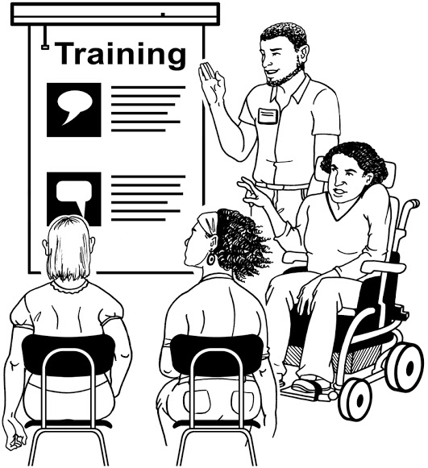
The Advisory Group will help the District Health Boards to use the plan.

Focus number 1: good health care

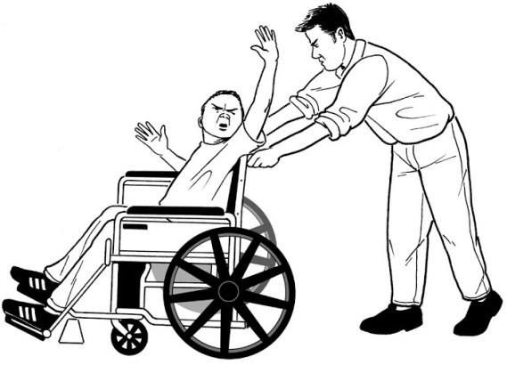
Sometimes disabled people have a hard time when they are at:
- the Doctors
- Hospital.

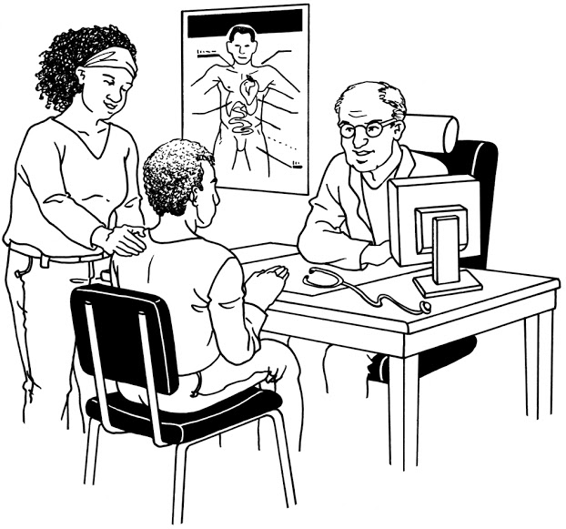
Some of the problems people have are:

- having lots of different people helping with their health care

- services not talking to each other.

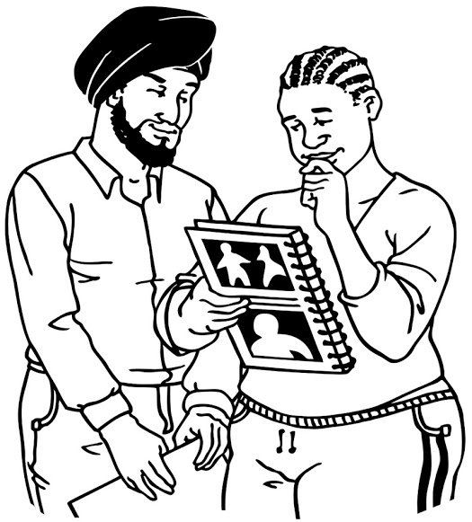
There needs to be more information about disability for health staff.

In the new Disability Plan:
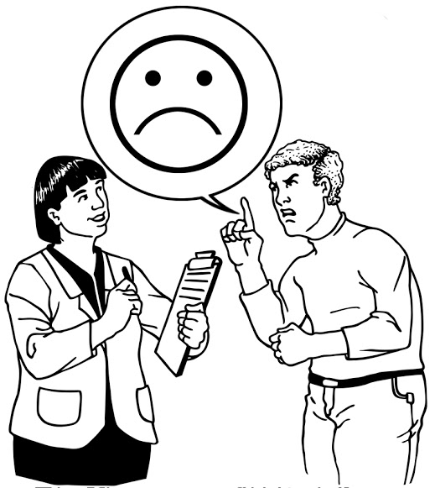

- The Health Board will get more information about what disabled people need help with.

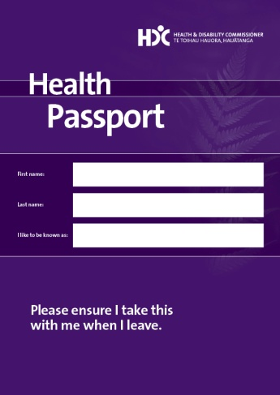

- Healthcare places need to use the Health Passport.

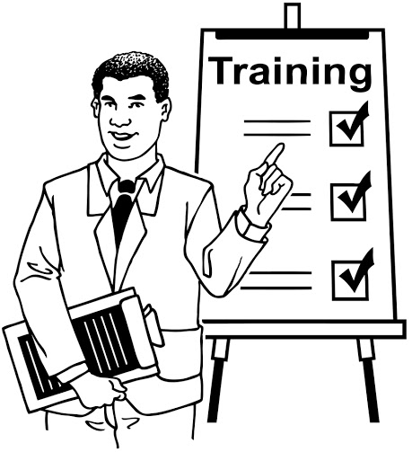
- Healthcare workers will have disability training.

The staff training will be:

- about how to really work better with disabled people

- something that staff do as part of their normal job.

Focus number 2: listening to disabled people

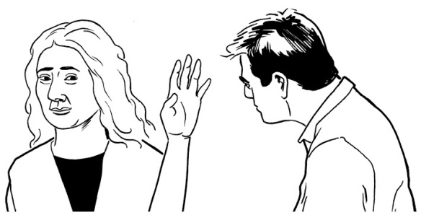

Disabled people do not always get to say what health care they want.

Disabled people want to have a say.

In the new Disability Plan:
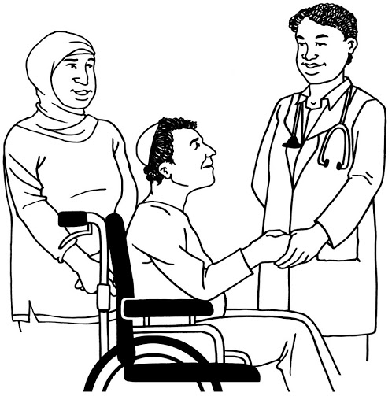

- Disabled people will be part of Health Board planning.

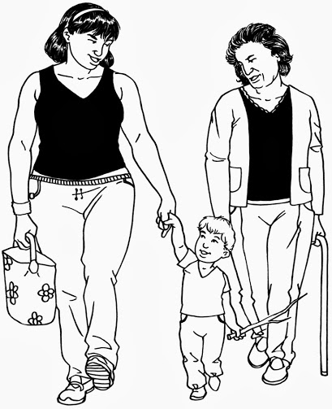
- Health services will support disabled people and their families.

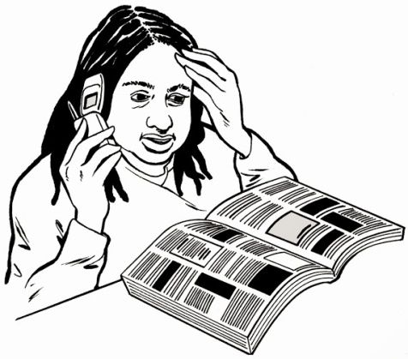
- A new phone book on health care in the region will be made by 14 July 2014.

- An action group will be checking that planners are listening to disabled people.

This will start in Wellington but it will soon cover the whole region.

Focus number 3: easy healthcare

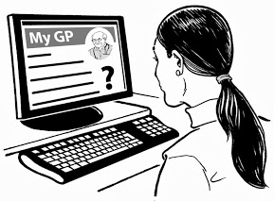
It needs to be easier for disabled people to get healthcare.

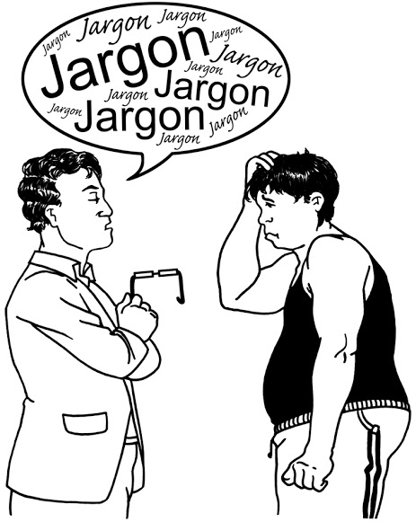
Some of the things that need to be better are:

- information

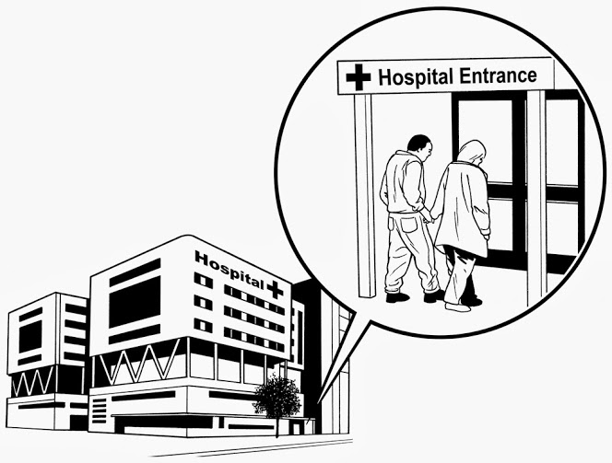
- parking

- Buildings

In the new Disability Plan:

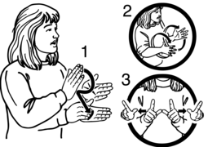
- The Health Board will make a rule about using sign language.

- All information for the public will be done in plain English.

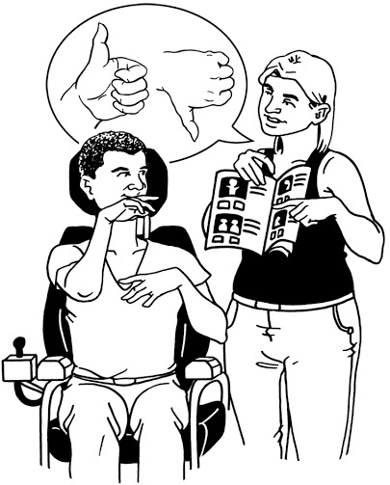

- All disability information will be done in Easy-Read.

- Healthcare buildings will be checked to see if they are easy to use.

- The Health Board will make a plan for any changes that need to be made.

Focus number 4: leadership

The health system can be hard to understand.

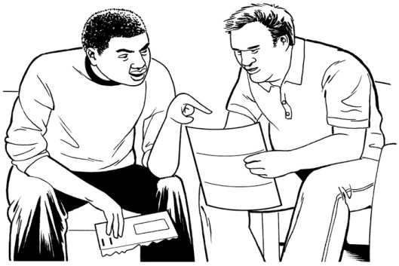
The Health Board wants the system to work better for people.

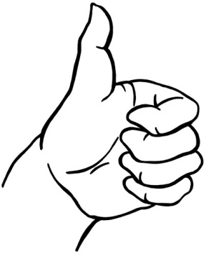
This will mean better health for disabled people.

In the new Disability Plan:

- The Health Boards will work together with leaders from the disabled community.

- Forums will be held every year.

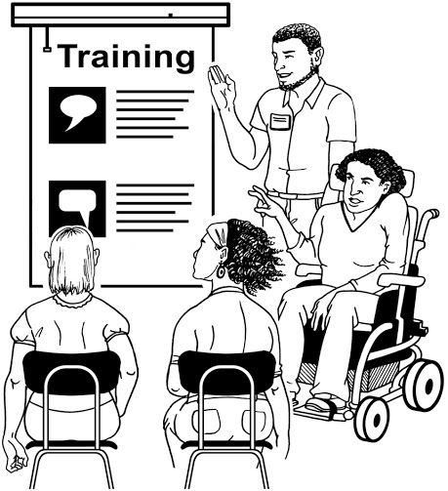

- There will be more jobs for disabled people in healthcare places.

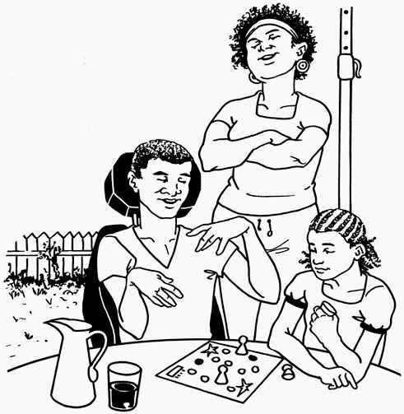
- The Health Boards will listen to what Māori and Pacific disabled people need.

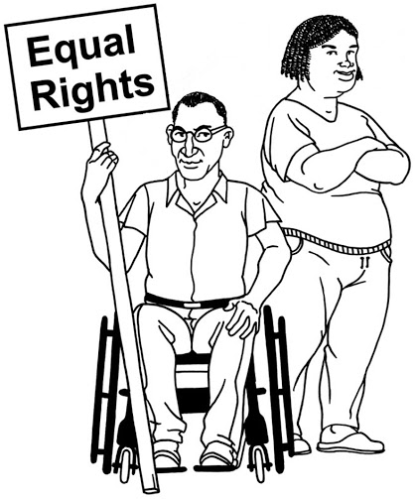
- This Health Board will be a leader in New Zealand for using the United Nations Disability Convention.

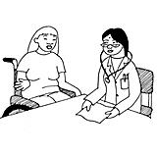
This will make things better for:

- all disabled people

- all health boards.

When will the new Disability Plan be ready?

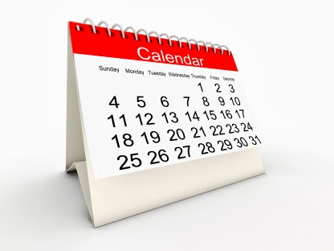

The new Disability Plan will be ready for the public after December 2014.

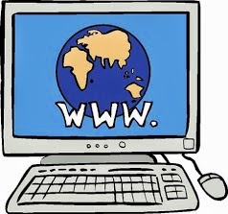
People will be able to find it on the:

- Capital and Coast District Health Board website

- Hutt Valley District Health Board website

- Wairarapa District Health Board website.

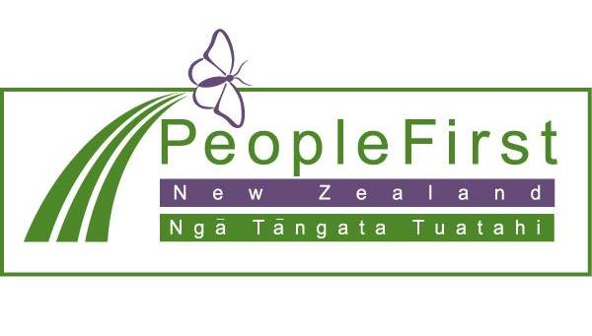

This information has been translated into Easy Read
by People First New Zealand Inc.- Ngā Tāngata Tuatahi

